Residency Project: Online Retail Data Mining Analysis

Srujana Nevoji
005035690
MSCS 634: Advanced Big Data and Data Mining
Satish Penmatsa

1. Introduction
Data mining provides organizations with methods to transform large amounts of raw data into meaningful information that supports better decision-making. Retail businesses generate substantial amounts of transactional data through everyday customer purchases. These records can contain valuable information about purchasing patterns, transaction values, product relationships, and customer behaviour. However, raw transactional data must first be cleaned, transformed, and analyzed before meaningful insights can be obtained.
The purpose of this project was to apply several data mining and machine learning techniques to a real-world Online Retail dataset. The project was completed through multiple deliverables that progressively moved from data preparation and exploratory analysis to predictive modelling and pattern discovery. The analysis included data cleaning, exploratory data analysis (EDA), feature engineering, regression modelling, classification, hyperparameter tuning, clustering, and association rule mining.
The first stage of the project focused on understanding and preparing the dataset. Missing information, duplicate records, cancelled transactions, and invalid values were identified and addressed prior to analysis. Exploratory visualizations were then used to understand sales distributions, transaction characteristics, product activity, and other patterns within the dataset.
The second stage extended the analysis through feature engineering and regression modelling. Transaction-level information was aggregated into invoice-level features that could be used to predict invoice sales. Multiple Linear Regression, Ridge Regression, and Lasso Regression were evaluated using several performance measures and cross-validation.
The third stage applied classification, clustering, and association rule mining. Decision Tree and k-Nearest Neighbours (k-NN) models were developed to classify transactions, and GridSearchCV was used to tune the Decision Tree. K-Means clustering was applied to identify naturally occurring groups of transactions, while the Apriori algorithm was used to identify products that frequently occurred together.
By combining these techniques, the project demonstrates how different data mining methods can provide complementary insights from the same retail dataset. The ultimate objective is not only to develop models but also to understand how the resulting information could support practical retail decisions involving sales, marketing, product recommendations, customer segmentation, and inventory management.

2. Dataset Description

2.1 Dataset Source
The dataset selected for this project was the Online Retail dataset available through the UCI Machine Learning Repository. The dataset contains transactional information from a UK-based online retailer and includes purchases made by customers from multiple countries.
The dataset was selected because it represents real-world transactional data and contains variables that can support several types of data mining analysis. Its transactional structure makes it appropriate for exploratory analysis, regression, classification, clustering, and market-basket analysis.
Dataset source:
UCI Machine Learning Repository – Online Retail
https://archive.ics.uci.edu/dataset/352/online-retail?utm_source=chatgpt.com

2.2 Dataset Structure
The original dataset contained:
Number of rows: 541909
Number of columns: 8
The major attributes used in this project included the following:
Attribute | Description
InvoiceNo | Unique identifier associated with an invoice or transaction
StockCode | Unique identifier assigned to a product
Description | Description or name of the purchased product
Quantity | Number of units purchased
InvoiceDate | Date and time when the transaction occurred
UnitPrice | Price per individual product unit
CustomerID | Identifier associated with a customer
Country | Country associated with the transaction
Figure 1. Sample records from the Online Retail dataset.
Figure 1 presents a sample of the original dataset. Each row represents an item included in an invoice rather than an entire customer order. Therefore, a single invoice can contain several rows when multiple products were purchased as part of the same transaction.

2.3 Reason for Selecting the Dataset
The Online Retail dataset was appropriate for this project because it contains a large number of transactional observations and provides both numerical and categorical information. Variables such as quantity, unit price, date, product description, invoice number, and country make it possible to study different aspects of retail purchasing behaviour.
The dataset also supports multiple analytical objectives. Numerical features can be used for regression modelling, invoice characteristics can be transformed into classification variables, transactions can be grouped using clustering, and individual products can be analyzed using association rule mining. Therefore, the same dataset provided an effective foundation for demonstrating several important data mining techniques.

3. Data Preparation and Cleaning
Data preparation was an important first stage because machine learning algorithms depend on the quality of the information provided to them. Raw transactional datasets may contain missing information, duplicates, cancellations, incorrect values, and extreme observations. These problems can affect statistical results and model performance if not addressed appropriately.

3.1 Missing Values
The dataset was initially examined for missing values. Missing information was particularly important in fields such as product descriptions and customer identifiers, as these variables were needed for subsequent analysis.
The analysis showed that:
Missing Description values: 1454
Missing CustomerID values: 135080
Records missing information required for the analysis were removed where appropriate. This provided a more consistent dataset for subsequent processing and modelling.

3.2 Duplicate Records
Duplicate records were examined and removed. Duplicate transactions could artificially increase product frequencies, transaction totals, or relationships between variables. Removing duplicates helped ensure that duplicate records did not influence the analysis.
Number of duplicates removed: 5268

3.3 Cancelled and Invalid Transactions
Cancelled invoices were identified through invoice numbers beginning with the letter "C." These transactions were excluded because they did not represent completed purchases.
Records with nonpositive quantities were also removed. Similarly, records with nonpositive unit prices were excluded because they were not appropriate for the sales-focused analysis.
These cleaning decisions ensured that the remaining dataset primarily represented valid completed purchases.

3.4 Data Type Conversion
The InvoiceDate variable was converted into a datetime format. This transformation was necessary because later stages of the project extracted additional temporal features such as month, day of the week, hour, and weekend status.
Product descriptions were also standardized to improve consistency when grouping products and performing association rule mining.

3.5 Creation of TotalSales
A new feature called TotalSales was created by multiplying the quantity purchased by the unit price:
TotalSales = Quantity × UnitPrice
This variable represents the monetary value associated with each product line in a transaction and became an important variable throughout the project.

3.6 Cleaned Dataset
Following preprocessing, the dataset contained:
Original records: 541909
Cleaned records: 524878
The cleaned dataset provided a more reliable foundation for exploratory analysis and machine learning. Removing incomplete, duplicate, cancelled, and invalid transactions reduced the possibility that data-quality problems would distort the results.

4. Exploratory Data Analysis
Exploratory Data Analysis was conducted to understand the characteristics of the cleaned dataset before developing predictive models. Visualizations and descriptive statistics were used to examine sales distributions, product activity, geographic patterns, and other important characteristics.

4.1 Sales Distribution

The sales distribution was highly right-skewed, with most transactions concentrated at relatively low sales values and a smaller number of transactions having much larger values. These extreme transactions may represent bulk or unusually large purchases. Because outliers can strongly influence regression models and distance-based clustering algorithms, their effect was considered during later stages of the analysis.

4.2 Product Purchasing Patterns
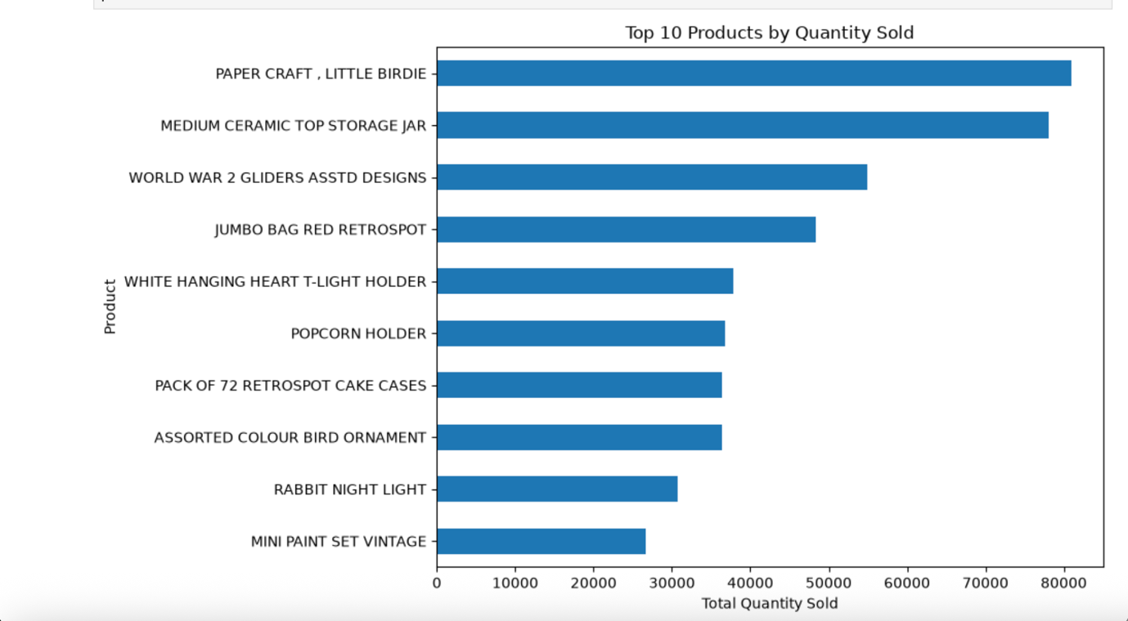
Figure 1. Most frequently occurring products in the dataset.
The product-frequency analysis showed that minimalist or tiny products are in high demand rather than expensive products. Some products appeared substantially more frequently than others, indicating differences in product demand.
These patterns are useful for retailers because frequently purchased products may require greater inventory availability and could also play an important role in cross-selling and recommendation strategies.

4.3 Geographic Analysis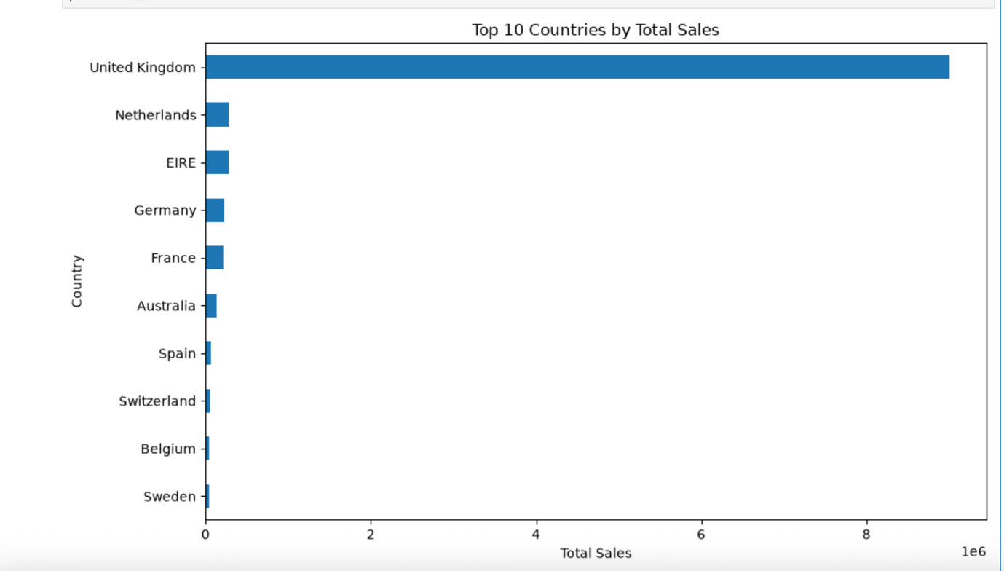

Figure 2. Transaction or sales activity by country.
The geographic analysis indicated that the main region of the product sales was in the UK. This data is UK-oriented, and it is reasonable to say that sales also occur in the same region. The dataset includes transactions from multiple countries, although purchasing activity was not necessarily distributed evenly across geographic regions.
This is an important consideration because a model trained on the entire dataset may reflect purchasing behaviour from regions with greater representation.

4.4 Additional EDA Findings
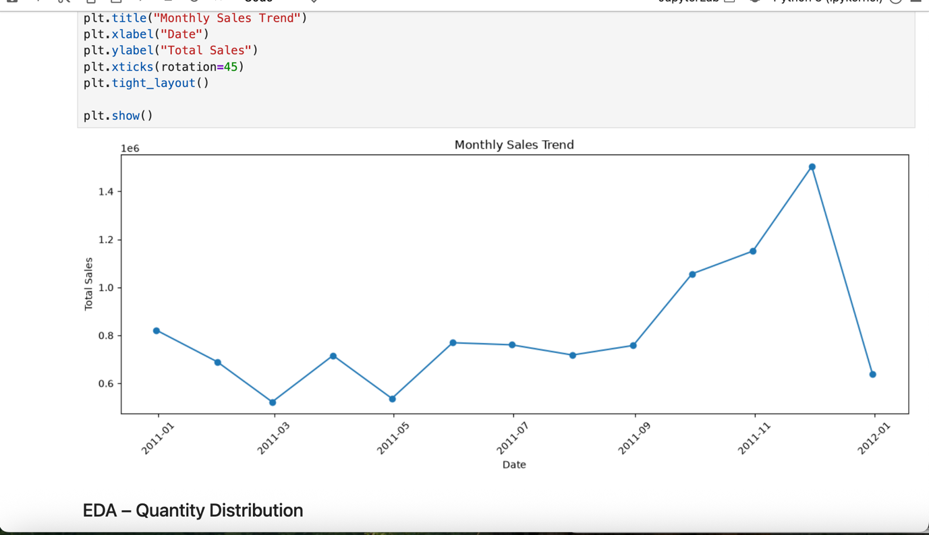
Figure 3. Monthly Sales Trend
This analysis demonstrated that most sales occurred at the end of the year when the gifting season happens.
Overall, the exploratory analysis provided information about the structure, distribution, and potential limitations of the dataset. These findings helped guide feature engineering and model selection in later stages of the project.

5. Feature Engineering
Feature engineering was performed to transform the cleaned transactional data into variables that could provide more meaningful information to the machine learning models.
The original Online Retail dataset contains individual product-level records. Because multiple products can belong to the same invoice, the data was aggregated to create invoice-level observations for regression and classification modelling.
The following features were created:
TotalQuantity: The total number of product units included in an invoice.
UniqueProducts: The number of different products included in an invoice.
AvgUnitPrice: The average unit price of products within an invoice.
Month: The month in which the transaction occurred.
DayOfWeek: The numerical day of the week when the transaction occurred.
Hour: The hour when the transaction was recorded.
Weekend: A binary feature indicating whether the transaction occurred during a weekend.
TotalSales: The total monetary value associated with the invoice.
These engineered features allowed the project to move beyond individual product records and analyze complete transactions. For example, TotalQuantity provides information about transaction size, while UniqueProducts measures the diversity of products purchased within an invoice. Temporal variables provide additional information about when the purchasing activity occurred.
Feature engineering was particularly important because the raw dataset was not originally designed specifically for predictive modelling. Transforming the transactional records created variables that were better aligned with the regression, classification, and clustering objectives of the project.

6. Regression Analysis

6.1 Objective
Regression analysis was conducted to predict invoice-level TotalSales using engineered transaction features.
Three regression approaches were evaluated:
- Multiple Linear Regression
- Ridge Regression
- Lasso Regression
The data was divided into training and testing sets. Feature scaling was applied where appropriate, and model performance was evaluated using multiple metrics.

6.2 Multiple Linear Regression
Multiple Linear Regression models the relationship between a continuous dependent variable and multiple independent variables. In this project, transaction characteristics were used to estimate invoice-level sales.
The model provided a baseline for comparison with regularized regression methods.

6.3 Ridge Regression
Ridge Regression extends linear regression by applying L2 regularization. Regularization penalizes excessively large model coefficients, which can help reduce overfitting and improve model stability when predictor variables are correlated.

6.4 Lasso Regression
Lasso Regression uses L1 regularization. In addition to controlling coefficient magnitude, Lasso can shrink some coefficients toward zero. This characteristic can make it useful when some predictors contribute less information than others.

6.5 Regression Model Evaluation
The models were evaluated using Mean Absolute Error (MAE), Mean Squared Error (MSE), Root Mean Squared Error (RMSE), and R-squared (R²).

Model | MAE | MSE | RMSE | R²
Multiple Linear Regression | 141.167949 | 58677.913713 | 242.235245 | 0.634831
Ridge Regression | 141.170853 | 58677.920803 | 242.235259 | 0.634831
Lasso Regression | 141.174940 | 58678.4669203 | 242.236391 | 0.634828
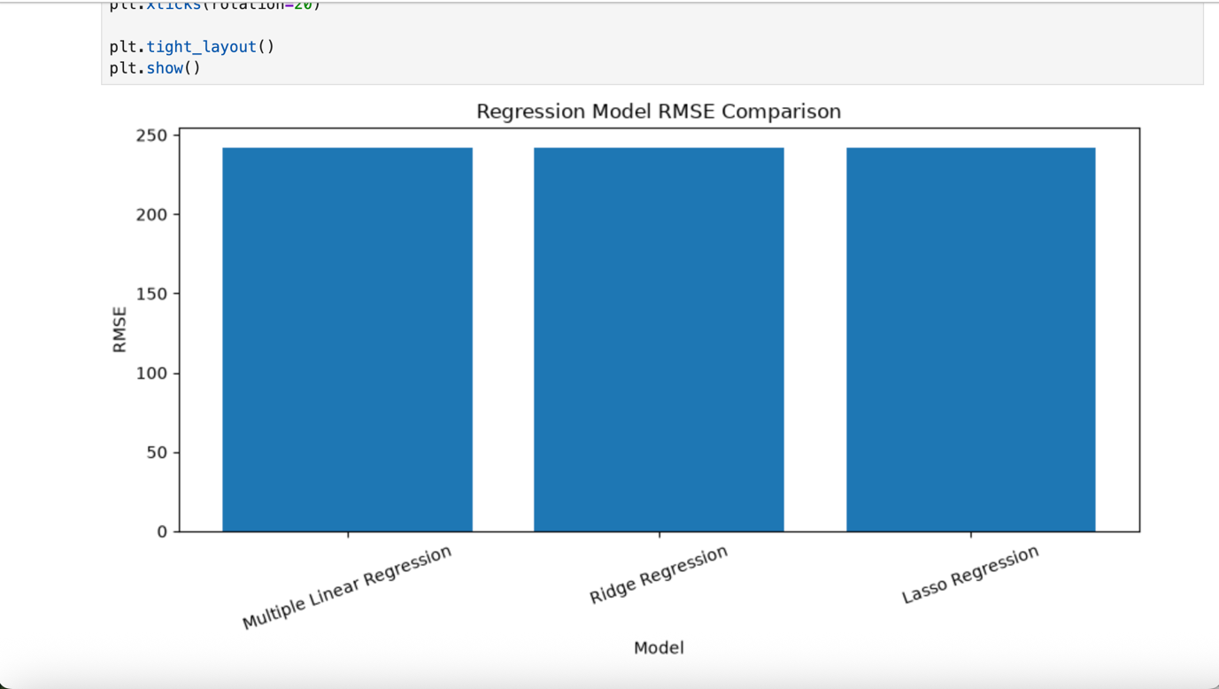
Figure 4. Comparison of regression model performance.
Lower MAE, MSE, and RMSE values represent smaller prediction errors. Higher R² values indicate that a greater proportion of variation in the target variable is explained by the model.

Based on the test-set results, Multiple Linear Regression produced the strongest overall performance, although the differences among the three models were extremely small. Multiple Linear Regression achieved the lowest MAE of 141.167949, the lowest RMSE of 242.235245, and an R² of 0.634831. Ridge Regression produced nearly identical results, while Lasso Regression had a slightly higher prediction error and a slightly lower R². Therefore, Multiple Linear Regression was selected as the best-performing regression model for this dataset.

6.6 Cross-Validation
Five-fold cross-validation was used to evaluate whether model performance remained reasonably consistent across different subsets of the data.
Model | Mean Cross-Validation R²
Linear Regression | 0.614323
Ridge Regression | 0.614323
Lasso Regression | 0.614323
The cross-validation results showed that all three regression models achieved nearly identical mean R² scores of 0.614323. This indicates that regularization through Ridge and Lasso did not provide a meaningful improvement over standard Multiple Linear Regression for the selected features. The cross-validation R² was slightly lower than the test-set R² of approximately 0.635, but the difference was not substantial. This suggests that the regression models demonstrated reasonably consistent performance and generalized to unseen subsets of the data without a major loss in predictive ability.

Based on both test-set metrics and cross-validation results, Multiple Linear Regression was selected as the strongest regression approach for this analysis. Its advantage over Ridge and Lasso was very small, however, which suggests that regularization had limited impact on this particular feature set.

7. Classification Analysis

7.1 Classification Objective
The Online Retail dataset does not contain a predefined classification target appropriate for the project's classification requirement. Therefore, a binary variable called HighValue was created using median invoice sales.
Transactions with TotalSales greater than the median were assigned:
1 = High-value transaction
Transactions at or below the median were assigned:
0 = Lower-value transaction
Using the median helped produce relatively balanced classes for classification.
Two models were evaluated:
- Decision Tree
- k-Nearest Neighbours (k-NN)

7.2 Decision Tree
A Decision Tree classifier uses a sequence of decision rules to separate observations into classes. The model can capture nonlinear relationships and is relatively easy to interpret.
The Decision Tree achieved:
Accuracy: 0.8456973293768546
F1 Score: 0.8443960826985855
ROC-AUC: 0.8456951350356954
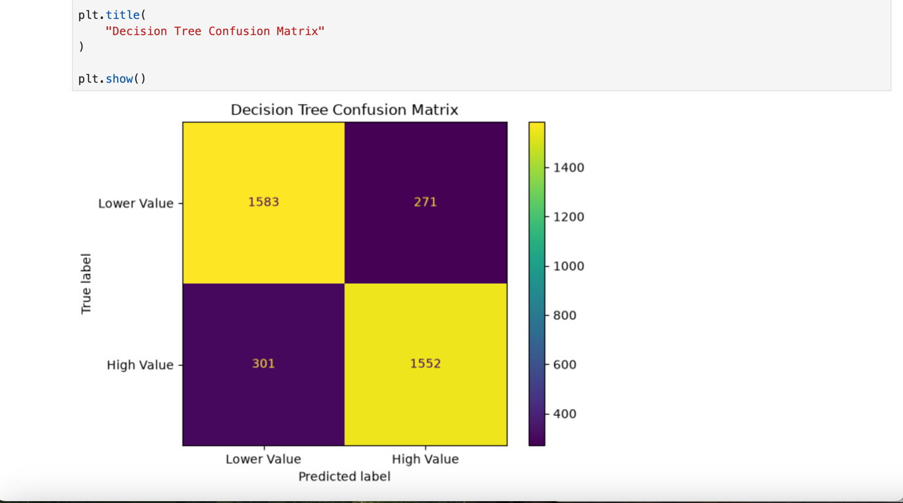
Figure 5. Decision Tree confusion matrix.

The confusion matrix showed that the Decision Tree correctly classified 1,583 lower-value transactions and 1,552 high-value transactions. The model incorrectly classified 271 lower-value transactions as high-value and 301 high-value transactions as lower-value. Overall, the relatively large number of correct classifications compared with incorrect classifications is consistent with the model's accuracy of approximately 84.6%.

7.3 k-Nearest Neighbours
The k-NN classifier predicts the class of an observation according to nearby observations in the feature space. Because k-NN relies on distance calculations, the predictor variables were standardized before model training.
The k-NN model achieved:
Accuracy: 0.755867278122471
F1 Score: 0.748121347063735
ROC-AUC: 0.8076255828182644

7.4 Classification Model Comparison
Model | Accuracy | F1 Score | ROC-AUC
Decision Tree | 0.845697 | 0.844396 | 0.845695
k-NN | 0.755867 | 0.748121 | 0.807626
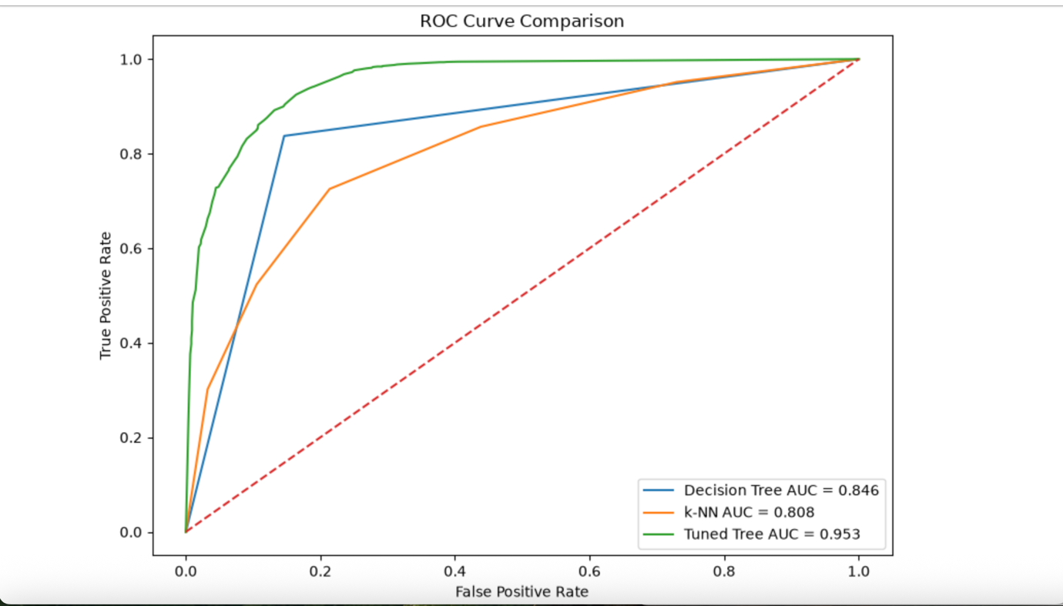
Figure 6. ROC curves for classification models.
The ROC curve illustrates the relationship between the true-positive rate and false-positive rate at different classification thresholds. A larger area under the ROC curve generally indicates stronger discrimination between the two classes.

Based on the evaluation results, the Decision Tree demonstrated better overall classification performance than k-NN. The Decision Tree achieved an accuracy of 0.845697, an F1 score of 0.844396, and a ROC-AUC of 0.845695. In comparison, k-NN achieved an accuracy of 0.755867, an F1 score of 0.748121, and a ROC-AUC of 0.807626. The Decision Tree, therefore, provided stronger performance across all three evaluation measures.

8. Hyperparameter Tuning
Hyperparameter tuning was performed on the Decision Tree classifier using GridSearchCV. Rather than relying on one manually selected model configuration, GridSearchCV systematically evaluated multiple parameter combinations.
The parameters examined included:
- max_depth
- min_samples_split
- min_samples_leaf
- criterion
Five-fold cross-validation was used during the tuning process, and F1 score was used as the optimization metric.
The best parameters identified were:
max_depth: 7
min_samples_split: 2
min_samples_leaf: 2
criterion: ‘entropy’
Best cross-validation F1 score: 0.8849647465897277
The original and tuned models produced the following results:
Model | Accuracy | F1 Score | ROC-AUC
Original Decision Tree | 0.845697 | 0.844396 | 0.845695
Tuned Decision Tree | 0.877529 | 0.880147 | 0.953112
Hyperparameter tuning improved the Decision Tree's performance. The tuned model achieved an accuracy of 0.877529, an F1 score of 0.880147, and a ROC-AUC of 0.953112, compared with an accuracy of 0.845697, an F1 score of 0.844396, and a ROC-AUC of 0.845695 for the original Decision Tree. The improvement was particularly noticeable in ROC-AUC, indicating that the tuned model was substantially better at separating high-value and lower-value transactions across different classification thresholds. The results suggest that limiting tree depth and controlling the minimum samples required for splits and leaves helped the model generalize better. This analysis demonstrates the importance of evaluating model complexity rather than assuming that a more complex model will always perform better.

9. Clustering Analysis

9.1 K-Means Clustering
K-Means clustering was applied to identify naturally occurring groups of transactions without using predefined class labels.
The following features were used:
- TotalQuantity
- UniqueProducts
- AvgUnitPrice
- TotalSales
Because K-Means uses distance calculations, the variables were standardized before clustering. Extreme observations were also considered because unusually large transactions can strongly influence cluster centres.

9.2 Selecting the Number of Clusters
The elbow method and silhouette score were used to evaluate different numbers of clusters.
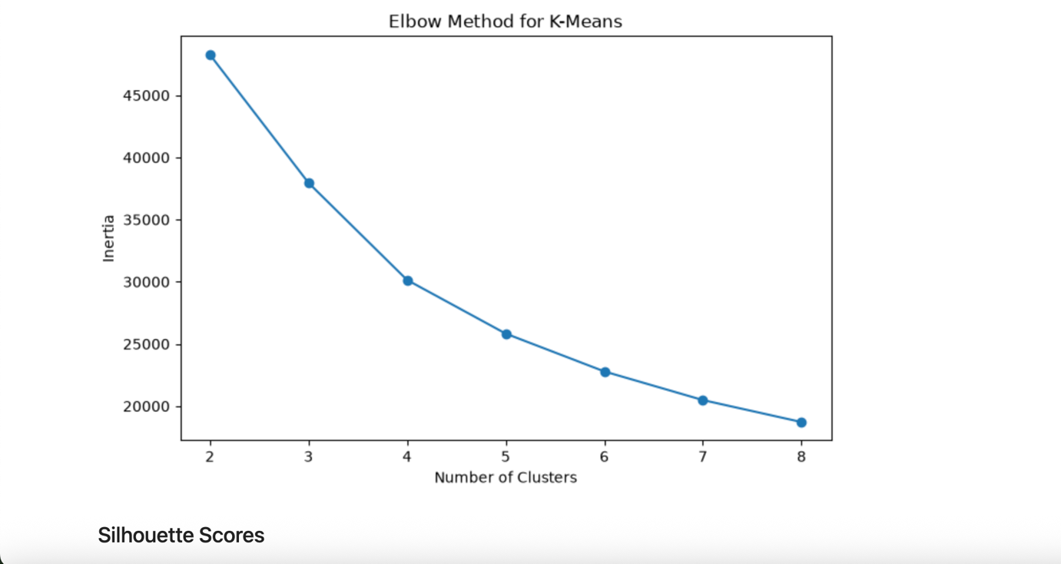
Figure 7. Elbow method for selecting the number of K-Means clusters.
The silhouette scores were:
k = 2: 0.42603372
k = 3: 0.34167690
k = 4: 0.32977708
k = 5: 0.32623414
k = 6: 0.28189930

Based on these results, k = 2 was selected for the final K-Means model because it produced the highest silhouette score of 0.42603372 among the tested values. The silhouette score declined as additional clusters were introduced, indicating that two clusters provided the clearest separation and cohesion for the selected transaction features. Although the elbow graph showed gradual improvement in inertia as more clusters were added, the silhouette analysis provided stronger evidence for using two clusters.

9.3 Cluster Results
The final clustering model produced the following average characteristics:
Cluster | Total Quantity | Unique Products | Avg. Unit Price | Total Sales
Cluster 0 | 133.334368 | 14.139099 | 3.385951 | 245.815852
Cluster 1 | 501.285164 | 38.796201 | 2.636749 | 774.734076
Final Silhouette Score: 0.42603372
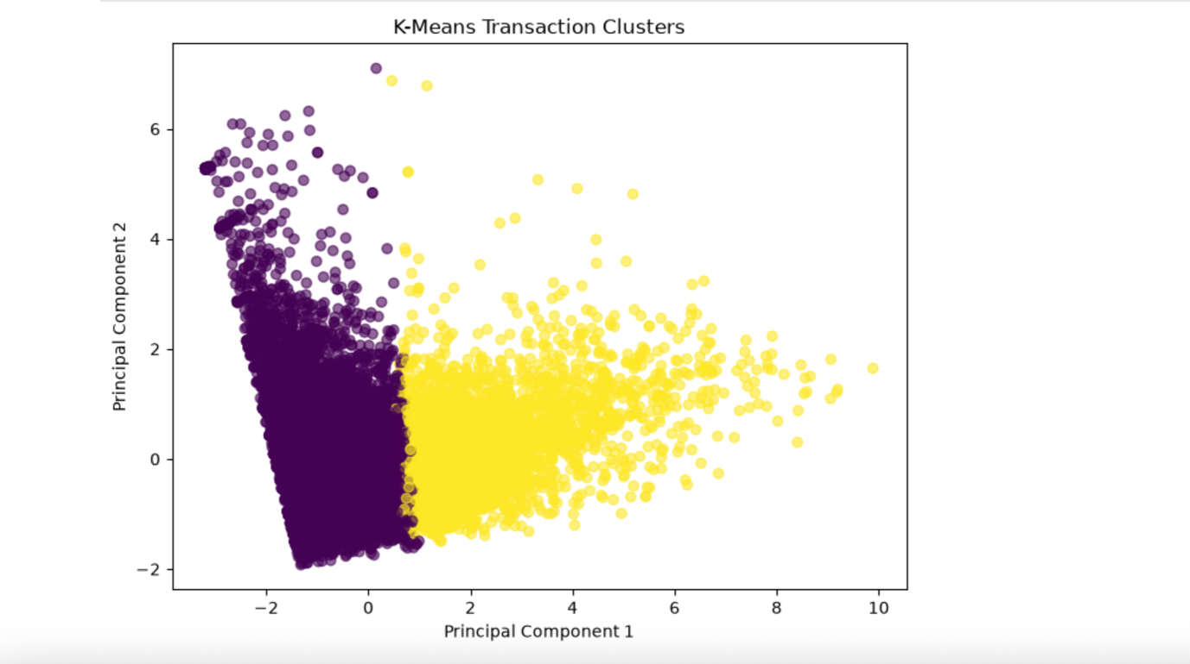
Figure 8. Visualization of transaction clusters using PCA.
The cluster profiles suggest that Cluster 0 represents smaller, lower-value transactions. Transactions in this group contained an average total quantity of approximately 133 units, about 14 unique products, an average unit price of approximately 3.39, and average total sales of approximately 245.82.
In contrast, Cluster 1 represents larger and higher-value transactions. Transactions in this cluster contained an average quantity of approximately 501 units, nearly 39 unique products, and an average total sales of approximately 774.73. Interestingly, Cluster 1 had a slightly lower average unit price of approximately 2.64, suggesting that its higher transaction values were driven more by the quantity and diversity of products purchased than by higher individual product prices.
From a business perspective, Cluster 0 could be interpreted as smaller purchasing occasions, while Cluster 1 represents larger-volume purchasing behaviour. Retailers could potentially develop different promotions, product recommendations, or loyalty incentives for these two transaction groups.

10. Association Rule Mining

10.1 Market-Basket Analysis
Association rule mining was performed using the Apriori algorithm. The purpose of this analysis was to identify products that frequently co-occurred in the same transaction.
Because market-basket analysis can become computationally intensive when thousands of unique products are included, FRANCE transactions were used for this portion of the analysis.
The minimum support threshold was set to 0.05, and association rules were generated using a minimum confidence threshold of 0 to 1.

10.2 Frequent Itemsets
Apriori identified 194 frequent itemsets meeting the selected minimum-support requirement.
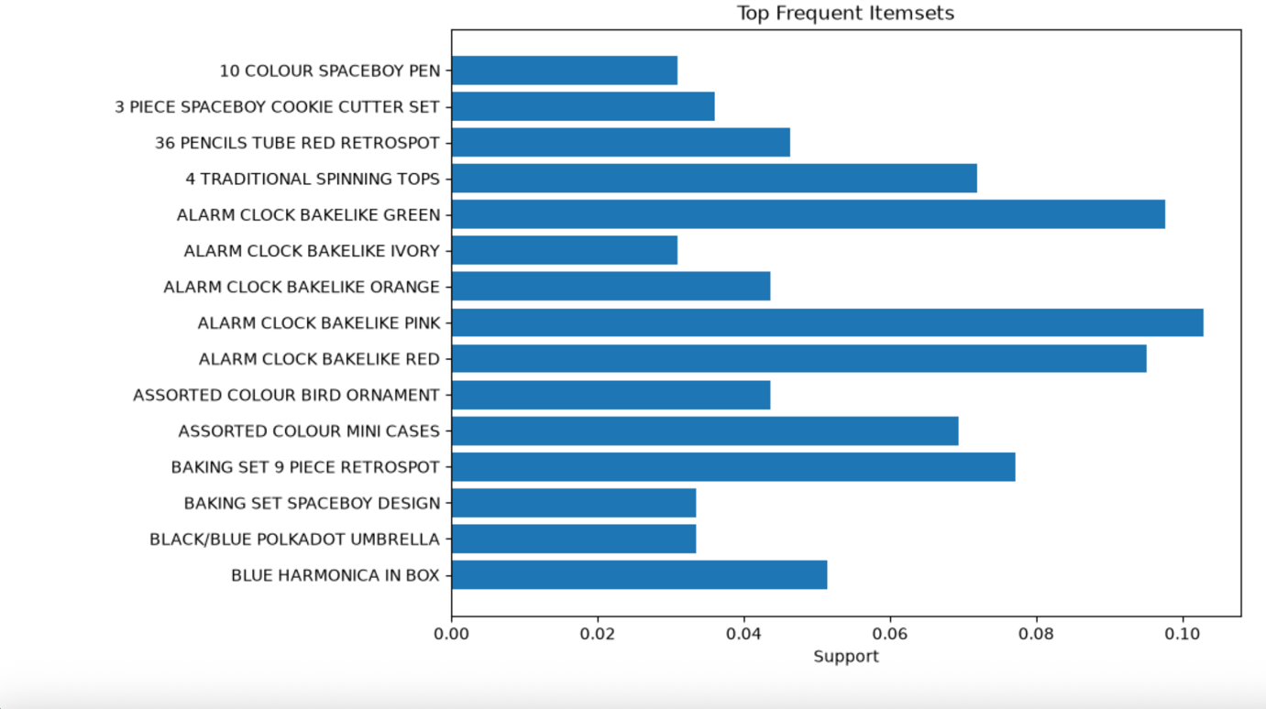
Figure 9. Most frequent itemsets discovered using Apriori.

The frequent-itemset results showed that several products occurred in a substantial proportion of the French transactions. ALARM CLOCK BAKELIKE PINK had one of the highest support values, followed closely by related products such as ALARM CLOCK BAKELIKE GREEN and ALARM CLOCK BAKELIKE RED. Other frequently occurring items included baking sets, spinning tops, pencil tubes, and decorative products. The presence of several related alarm-clock products among the most frequent itemsets suggests consistent demand for this product family and indicates potential opportunities for related-product recommendations.

10.3 Association Rules
Association rules were evaluated using support, confidence, and lift.
Support measures how frequently an item or item combination occurs in the transaction dataset.
Confidence measures how frequently the consequent occurs when the antecedent occurs.
Lift compares the observed relationship with what would be expected if the products were purchased independently. A lift greater than 1 indicates a positive association.
Some of the strongest rules discovered were: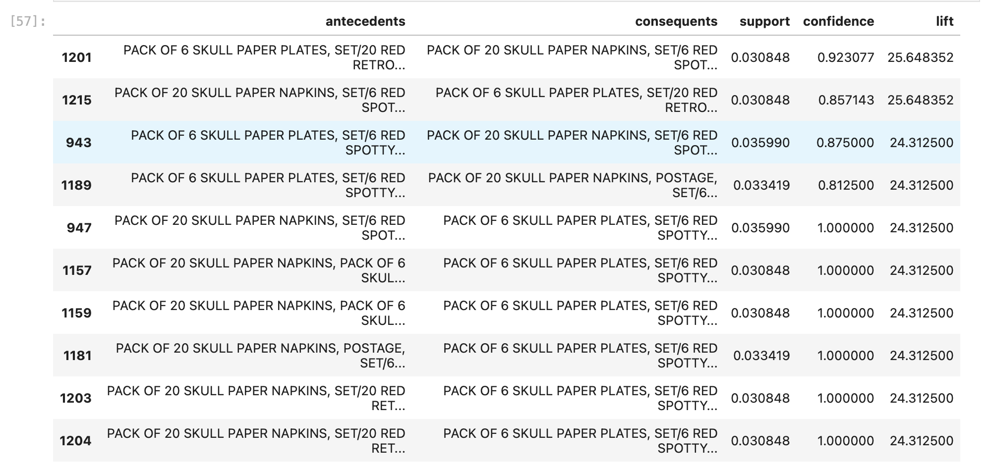
Figure 10. Strong association rules.

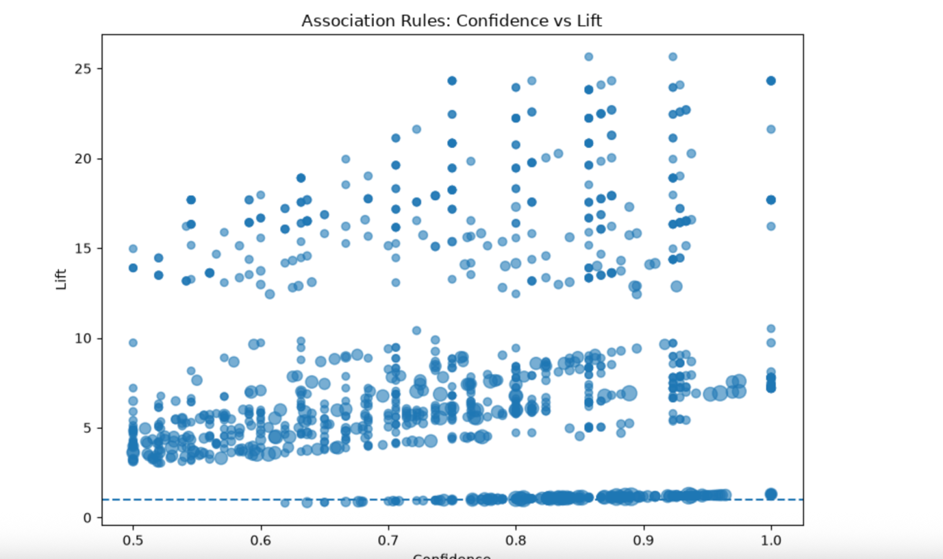

Figure 11. Confidence and lift of association rules.
The relationship between PACK OF 20 SKULL PAPER NAPKINS and PACK OF 6 SKULL PAPER PLATES was particularly noteworthy. Several rules involving these products yielded very high confidence values, including rules with confidence 1.00 and lift values above 24. This indicates that the products were purchased together far more frequently than would be expected if their purchases were independent. The strong relationship suggests that these products belong to a common purchasing theme and may be particularly suitable for product bundles, cross-selling recommendations, or coordinated promotional campaigns. Association rules such as these can provide practical information for retailers by identifying products that may be appropriate for recommendations, bundles, cross-selling campaigns, or coordinated inventory planning.

11. Overall Key Findings
The project produced several important findings across the different stages of analysis.
First, data preprocessing demonstrated the importance of cleaning transactional information before performing analysis. Missing values, duplicate records, cancelled invoices, and invalid quantity or price values were identified and handled. Exploratory analysis also revealed that sales were strongly concentrated in the United Kingdom, a relatively small group of products accounted for high purchase quantities, and monthly sales increased substantially toward the end of the year. These findings suggest both geographic concentration and seasonal purchasing behaviour..
Second, feature engineering made it possible to transform individual product records into meaningful invoice-level observations. Variables such as total quantity, number of unique products, average unit price, and transaction timing provided additional information for predictive modelling.
The regression analysis showed that Multiple Linear Regression provided the strongest overall performance, achieving an R² of 0.634831 and an RMSE of 242.235245. The mean cross-validation R² was 0.614323, indicating reasonably consistent predictive performance across unseen subsets of the data. Ridge and Lasso produced nearly identical results, suggesting that regularization provided limited additional benefit for the selected features.
For classification, the tuned Decision Tree achieved the strongest overall results with an accuracy of 0.877529, an F1 score of 0.880147, and a ROC-AUC of 0.953112. Hyperparameter tuning clearly improved the Decision Tree compared with its original configuration and also produced stronger performance than k-NN.
K-Means clustering identified 2 meaningful transaction groups. The clusters differed in characteristics such as transaction quantity, product diversity, average unit price, and total sales. These differences demonstrate how unsupervised learning can reveal patterns without predefined labels.
Finally, association rule mining identified product combinations that appeared together more frequently than expected. The strongest patterns included relationships between SKULL-themed paper napkins and matching paper plates, while several ALARM CLOCK BAKELIKE products also appeared frequently in the French transaction subset.
Overall, the combination of predictive and descriptive data mining techniques provided a broader understanding of the retail dataset than any single analytical method could provide alone.

12. Practical Recommendations
The results of this project can support several practical retail strategies.
One important recommendation is to use association-rule results to improve product recommendations and cross-selling. When two products consistently demonstrate strong confidence and lift, a retailer could recommend one product when a customer adds the other to their shopping cart. Strongly associated products could also be offered as bundles or displayed together in an online storefront.
The classification analysis could also support identifying transactions that exhibit characteristics associated with higher transaction values. Understanding the features associated with these transactions may help retailers design promotions or product recommendations intended to increase customer engagement and order value. However, model predictions should be treated as decision-support information rather than guaranteed descriptions of customer behaviour.
The clustering analysis provides another opportunity for targeted strategies. Different transaction clusters may represent customers making small routine purchases, larger diversified orders, or other distinct shopping patterns. Retailers could develop different communication, promotional, or recommendation strategies for these groups rather than applying the same approach to every transaction.
Inventory planning could also benefit from the analysis. Frequently purchased products should be monitored to ensure appropriate availability. Furthermore, products that demonstrate strong associations may experience related demand. Understanding these relationships could help retailers coordinate stock levels for products commonly purchased together.
Finally, the project demonstrates the value of combining multiple analytical methods. Regression can help estimate numerical outcomes, classification can identify transaction categories, clustering can reveal naturally occurring groups, and association-rule mining can identify relationships between products. A retailer could integrate insights from all four methods into a broader data-driven decision-making process.

13. Ethical Considerations

13.1 Data Privacy
Data privacy is an important consideration when analyzing retail transaction data. Purchasing histories can reveal information about customer preferences and behaviour. Even when a dataset does not contain customer names, identifiers such as CustomerID could potentially be linked with other information in a real organizational environment.
Organizations should therefore restrict access to customer-level data, remove unnecessary personally identifiable information, and use anonymization or pseudonymization where appropriate. Data should only be retained and analyzed for legitimate purposes and in accordance with applicable privacy requirements.
This project primarily focused on transaction characteristics rather than attempting to identify individual customers. Customer identifiers were not used as direct predictive features in the final models.

13.2 Fairness
Machine learning models should not be used in ways that unfairly disadvantage particular customers or groups. For example, a prediction that a transaction is likely to be of lower value should not automatically result in poorer service or exclusion from beneficial opportunities.
Model predictions represent statistical relationships in historical data and should not be interpreted as definitive judgments about individuals.

13.3 Potential Bias
The Online Retail dataset represents transactions associated with a particular retailer and a historical time period. Therefore, the purchasing patterns observed in the dataset may not represent every retailer, geographic market, or customer population.
Geographic representation is another potential source of bias. If certain countries account for substantially more transactions than others, models trained on the entire dataset may more strongly reflect purchasing patterns from the most represented locations.
The classification target was also constructed using median invoice sales rather than an externally defined business label. Although this provided a practical target for demonstrating classification techniques, the meaning of "high value" in a real organization would depend on its business objectives and customer strategy.

13.4 Responsible Interpretation
Clustering also requires responsible interpretation. A cluster represents statistical similarity among observations and does not mean that every customer or transaction within the group is identical.
Similarly, association does not establish causation. If two products frequently appear together, the analysis demonstrates a purchasing relationship but does not prove that purchasing one product causes the purchase of another.
For these reasons, the results should support human decision-making rather than automatically replace business judgment.

13.5 Steps Taken to Reduce Concerns
Several decisions helped improve the responsible use of the data. Invalid and incomplete records were addressed before modelling, unnecessary customer-identifying information was not used as a predictive feature, and models were evaluated using multiple performance measures rather than a single metric.
The project also recognizes the limitations of the dataset and avoids assuming that historical relationships will necessarily remain identical in future customer populations.

14. Challenges and Limitations
Several challenges were encountered during the project.
One initial challenge involved data quality. The original dataset contained missing values, duplicates, cancelled invoices, and invalid transaction values. These issues required preprocessing before meaningful analysis could be performed.
Another challenge involved converting product-level transaction data into information suitable for machine learning. Invoice-level aggregation and feature engineering were necessary to create meaningful predictors for regression and classification.
Outliers also presented a challenge because retail transaction data can contain unusually large quantities or sales values. Extreme observations can substantially influence regression coefficients and K-Means cluster centres. Appropriate filtering and percentile-based approaches were therefore considered during modelling.
The dataset did not contain a predefined classification label suitable for the project requirement. This challenge was addressed by creating a binary HighValue target using median invoice sales. While this approach enabled classification analysis, it represents an analytical definition rather than a retailer-defined business category.
Selecting the appropriate number of K-Means clusters was another challenge. The elbow method and silhouette score were used together, rather than selecting the number of clusters arbitrarily.
Association-rule mining also introduced computational challenges because the dataset contains many transactions and unique products. A smaller geographic subset and a minimum-support threshold were used to make the Apriori analysis computationally manageable.
Technical challenges were also encountered while working with Jupyter Notebook and installing required Python packages. These issues were addressed by verifying the Python environment, installing the necessary packages through the active Jupyter environment, and testing each stage incrementally.
Despite these challenges, each issue provided practical experience with problems commonly encountered when working with real-world data.

15. Future Improvements
Several improvements could extend this project in future work.
First, additional machine learning models could be evaluated. Random Forest, Gradient Boosting, and other ensemble techniques could be compared with the existing regression and classification models.
Classification could also be expanded by evaluating Support Vector Machines or other algorithms and performing more extensive hyperparameter tuning. Additional cross-validation strategies could provide stronger evidence of model generalization.
The clustering analysis could be expanded by comparing K-Means with DBSCAN or Hierarchical Clustering. Different methods may reveal alternative structures within the transaction data, particularly when clusters are irregularly shaped or contain substantial noise.
Customer-level behavioural analysis would also be a valuable extension. Features based on recency, frequency, and monetary value could be created to study longer-term customer purchasing behaviour rather than individual invoices.
Association-rule mining could be expanded to additional countries or the complete dataset using more computationally efficient methods such as FP-Growth. Recommendation system techniques could then be developed using the discovered product relationships.
Finally, future models should be evaluated using newer or out-of-time data. Retail purchasing behaviour can change because of seasonality, economic conditions, product availability, and customer preferences. Testing models on later data would provide a stronger assessment of whether the discovered relationships remain useful over time.

16. Conclusion
This project demonstrated the application of several important data mining techniques to a real-world Online Retail dataset. The project began with raw transactional data and progressed through data cleaning, exploratory analysis, feature engineering, regression, classification, hyperparameter tuning, clustering, and association rule mining.
Data preprocessing demonstrated that meaningful analysis requires careful attention to missing information, duplicates, cancelled transactions, invalid values, and extreme observations. Exploratory analysis provided insight into sales and product patterns, while feature engineering transformed individual product records into machine-learning-ready variables.
Regression analysis evaluated the ability to predict transaction sales, while classification models demonstrated how transactions could be categorized according to their characteristics. Hyperparameter tuning demonstrated how systematic model optimization can improve or control model performance. K-Means clustering provided an unsupervised perspective by identifying groups without predefined labels, while Apriori association-rule mining identified relationships among products purchased together.
The project also demonstrated that different data mining methods answer different types of questions. Regression estimates continuous outcomes, classification predicts predefined categories, clustering discovers naturally occurring groups, and association-rule mining identifies relationships among items. Combining these approaches can provide a more comprehensive understanding of retail transaction data.
From a practical perspective, the findings can support product recommendations, cross-selling, transaction segmentation, marketing strategies, and inventory planning. At the same time, data privacy, fairness, bias, and responsible interpretation must be considered whenever analytical models are applied to customer data.
Overall, this project provided practical experience with the complete data mining process, from preparing raw data to developing models and translating analytical findings into potential business recommendations. It also demonstrated the importance of evaluating models critically and recognizing that machine learning results should support informed decision-making rather than replace human judgment.

References
Chen, D. (2015). Online retail [Data set]. UCI Machine Learning Repository. https://doi.org/10.24432/C5BW33
Chen, D., Sain, S. L., & Guo, K. (2012). Data mining for the online retail industry: A case study of RFM model-based customer segmentation using data mining. Journal of Database Marketing & Customer Strategy Management, 19, 197–208.
Han, J., Pei, J., & Tong, H. (2022). Data mining: Concepts and techniques (4th ed.). Morgan Kaufmann.

